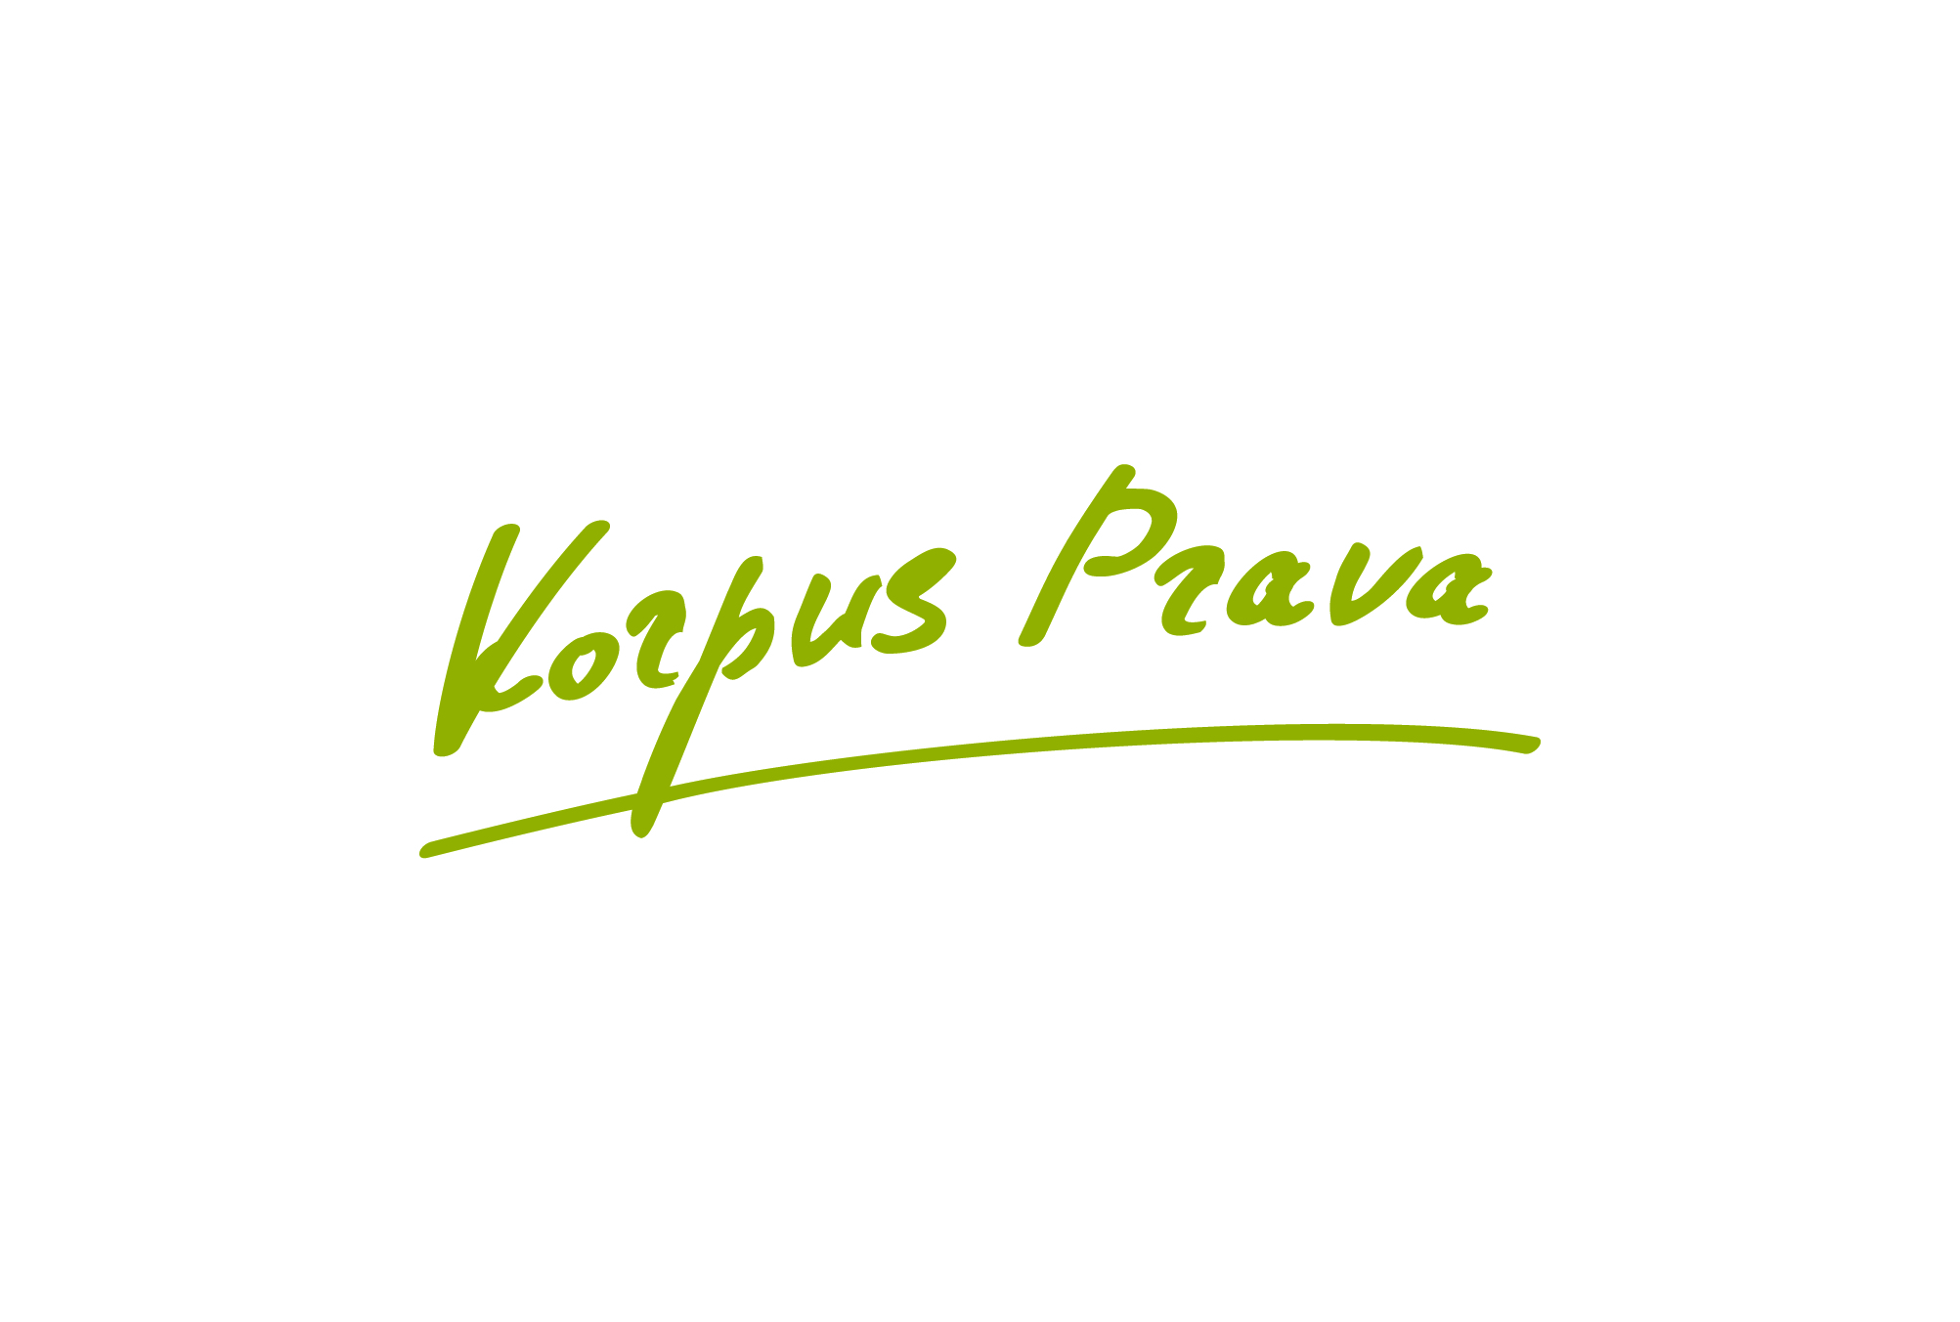

NEW CAYMAN ISLANDS FUND
INFORMATION REQUIRED
QUESTIONNAIRE TO FORM A CAYMAN ISLANDS FUND
FUND STRUCTURE
NAME OF FUND |  |  |  |  | Recommended name structure of a Fund:  [brand][region][type] Fund  example:  Tinkoff Emerging Equity Arbitrage Fund
TYPE OF ENTITY (e.g. company, limited partnership, unit trust) |  |  |  |  | Exempted Company
PROMOTER (FOUNDER) |  |  |  |  | Name, Registered Address
INVESTMENT PHILOSOPHY
INVESTMENT OBJECTIVE |  | Example:  [The investment objective of the Fund is to achieve long term capital growth and deliver absolute capital appreciation by investing the Fund's assets predominantly in various liquid equities and less liquid equities of companies whose principal operations or assets are located in the Russian Federation or other CIS countries as well as investing into securities, following the Investment Manager proprietary approach]
INVESTMENT POLICY |  | Example:  [The Investment Manager will allocate the assets of the Fund across equity of companies operating in Russia and/or the CIS countries, as well as various securities related to Russia and CIS countries such as, but not limited to, Russian or CIS countries’ ADRs (American Depositary Receipts issued by companies incorporated or established in Russia or the CIS countries or related to Russia or CIS countries in part or in whole of their business activities); shares of Russian and/or CIS countries’ and Russia and/or CIS countries related companies, rouble or other currency denominated fixed income instruments issued by Russian (or if applicable – CIS counties) federal, sub-federal and municipal governments, government agencies, government controlled or owned entities, corporate issuers and bank and finance companies; credit linked instruments; notes, including promissory notes; derivatives; structured products; commodities and derivative products, shares of other investment funds.  No rating criteria have been established for the securities in which the Fund may invest.  The Investment Manager's judgement and analysis using quantitative, technical and other methods is applied in the investment process.  The Fund is actively managed and may employ various strategies, such as, but not limited to directional trading, equities long and short, risk arbitrage, convertible arbitrage, relative value trading, multi-strategy, etc, at the time and in part that the Investment Manager believes it is appropriate to do so. Although the Investment Manager will generally try to avoid concentration risk, the important part of the Fund’s portfolio will usually be allocated in such asset class or classes and such instruments or issuers that represent in the opinion of the Investment Manager most gain potential.  The Investment Manager has the ability to use any financial instruments, can leverage the assets and can take short positions in any asset class. ]
INVESTMENT RESTRICTIONS |  | The minimum restrictions are recommended:  The Fund will generally observe the following investment restrictions:  (a) The Fund will adhere to the general principle of diversification in respect of all its assets;  (b) Management control of the underlying investments will not be taken;  (c) Up to 40% of the assets of the Fund may also be invested in other funds provided that such funds operate on the principle of risk spreading. Investment in other fund(s) will generally be made in money market funds for cash management purposes, risk diversification and yield enhancement;  (d) Investments in real estate, physical commodities or fund of funds are not allowed.
TYPES OF INVESTMENT (e.g. equities, bonds, derivatives) |  |  |  |  |  | Russian, CIS countries' and Russia and CIS related stakes, securities (equities, bonds, notes, ADRs, CLN, derivatives). Predominantly equities.
BORROWING AND LEVERAGE |  |  |  |  |  | Allowed in all cases. Limit 500% of net asset size.
SINGLE OR MULTI CLASS SHARE CAPITAL |  |  |  |  |  | Single class
DESCRIPTION OF EACH CLASS (if applicable)
CURRENCY OF ACCOUNT (and denomination of shares if different) |  |  |  |  |  | USD
LIKELY AND ANY MAXIMUM SIZE OF FUND |  |  |  |  |  | Likely size : $30 mln.  Maximum size : not set
PARTIES, ADVISERS AND FEES
INVESTMENT MANAGER |  |  |  |  | The name that is planned
AGENT |  |  |  |  | Name, Registered Address
FEES |  |  |  |  | MANAGEMENT FEE: 1,5% p.a.  PERFORMANCE FEE: 20% of the profits in excess of 5% p.a.
CUSTODIAN (if any) |  |  |  |  | None
PRINCIPAL/PRIME BROKER |  |  |  |  | Name, Registered Address
OTHER ADVISORS (if any) |  |  |  |  | Name, Registered Address
OTHER FEATURES
FREQUENCY OF DEALING FOR SUBSCRIPTIONS |  |  |  |  | Recommended:  Monthly
Redemption Lock-Up Period |  |  |  |  | 6 (six) months
Maximum year-end redemption: |  |  |  |  | 20% of the total net assets of the fund within 1 year, unless authorized by the directors
Minimum holding requirement |  |  |  |  | 100,000 USD
Redemption notice |  |  |  |  | Notice period: at least 1 (one) month
IN SPECIE SUBSCRIPTIONS/REDEMPTIONS? |  |  |  |  | Allowed
MINIMUM SIZE OF FUND |  |  |  |  | If the NAV of any fund is less than $1 (one) mln the directors have the right to wind up
MINIMUM INVESTMENT PER SHAREHOLDER ($100,000 absolute minimum) |  |  |  |  | $100,000 (one hundred thousand US Dollars)
DIVIDEND POLICY |  |  |  |  | No dividends, all current income is capitalised
IF APPLICABLE, IS EQUALISATION TO BE OPERATED? |  |  |  |  | Yes
CONFLICTS OF INTEREST |  |  |  |  | Regular wording
REPORTS, ACCOUNTS AND FISCAL YEAR |  |  |  |  | 31 December, reports at each valuation date, annual audit

